34.17: a) For we have:
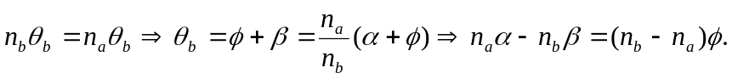
But 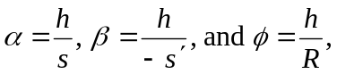so subbing them in one finds:
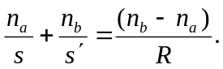
Also, the magnification calculation yields:
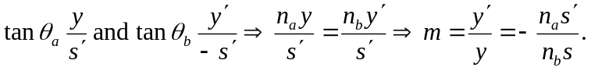
b) For
so subbing them in one finds: Also, the magnification calculation yields:
